# TITLE PAGE

**INDUSTRIAL TRAINING EVALUATION SYSTEM (ITEMS) (CASE STUDY OF FEDERAL POLYTECHNIC, MUBI)**

**BY**

**TIMOTHY HABILA**

**ST/CS/ND/21/048**

**DEPARTMENT OF COMPUTER SCIENCE,**

**SCHOOL OF SCIENCE AND TECHNOLOGY,**

**FEDERAL POLYTECHNIC, MUBI, ADAMAWA STATE.**

**IN PARTIAL FULFILLMENT OF THE REQUIREMENT FOR THE AWARD OF NATIONAL DIPLOMA (ND) IN COMPUTER SCIENCE.**

**SEPTEMBER, 2023**

# DECLARATION

I hereby declare that the work in this project titled **“Industrial Training Evaluation System (Items) (Case Study of Federal Polytechnic, Mubi)”** was performed by me under the supervision of Mr. Nuhu Abdullahi. The information derived from literatures has been duly acknowledged in the text and a list of references provided. The work embodied in this project is original and had not been submitted in part or in full for any other diploma or certificate of this or any other institution.

Timothy Habila _____________ _______________

(ST/CS/ND/21/048) Signature Date

# CERTIFICATION

This project work titled **“Industrial Training Evaluation System (Items) (Case Study of Federal Polytechnic, Mubi)”** meets the regulations governing the award of National Diploma (ND) in Computer Science, Federal Polytechnic Mubi, Adamawa State

Mr. Nuhu Abdullahi __________________

(Project Supervisor) Sign/Date

Mr. Mustapha Kassim __________________

(Head of Department) Sign/Date

_______________________ _________________

(External Examiner) Sign/Date

# DEDICATION

I dedicate this project work to Almighty God for granting me the ability to accomplish this work successfully.

# ACKNOWLEDGEMENTS

I want to acknowledge Almighty God for his infinite mercy and protection throughout my academic activities. And for the understanding in achieving my academic success.

I also recognize my Supervisor Mr. Nuhu Abdullahi, who took time, despite his busy schedule to direct and guide me throughout this research work.

I also acknowledge the Head of Department Computer Science Mr. Mustapha Kassim for his moral encouragement throughout my period of study. I also acknowledge all Staff of Computer Science Department for their support and encouragement and the knowledge they’ve impacted on me throughout my studies.

I also want to appreciate my parents for their love and care and for giving me the opportunity to be trained and achieve our dreams.

Finally, I appreciate the efforts of my Uncles and aunties, for their encouragement and support throughout the course of my study and also my friends and relatives, course mates and all well-wishers. I love you all, may the Almighty God bless you abundantly, Amen.

**TABLE OF CONTENTS**

TITLE PAGE i

DECLARATION ii

CERTIFICATION iii

DEDICATION iv

ACKNOWLEDGEMENTS v

LIST OF FIGURES viii

LIST OF TABLES ix

CHAPTER ONE INTRODUCTION 1

1.1 Background to the study 1

1.2 Problem statement 2

1.3 Aim and Objectives 3

1.4 Significance of the study 3

1.5 Scope of the Study 3

1.6 Definition of some Operational Terms 4

CHAPTER TWO 5

LITRATURE REVIEW 5

2.1 Introduction 5

2.2 Overview of online logbook for SIWES students 5

2.2.1 History of SIWES 5

2.3 Related works 6

CHAPTER THREE 11

SYSTEM ANALYSIS AND DESIGN 11

3.1 Introduction 11

3.2 Disadvantages of the existing system 11

3.3 Advantages of the proposed system 11

3.4 The proposed method 11

3.5 Methods of data collection 11

3.6 System design 12

3.6.1 Algorithm diagrams 12

3.6.2 System Architecture 14

3.6.3 Database tables/queries structures 15

3.6.4 Input and output design 17

CHAPTER FOUR 22

RESULTS AND DISCUSSION 22

4.1 Introduction 22

4.2 Results 22

4.3 Discussion 26

4.4 User manual 27

CHAPTER FIVE 28

SUMMARY, CONCLUSION AND RECOMMENDATION 28

5.1 Summary 28

5.2 Conclusion 28

5.3 Recommendations 28

5.4 Contribution to knowledge 28

5.5 Area for further work 28

REFERENCES 29

APPENDICES 31

# LIST OF FIGURES

Figure 3.1: Use case diagram - - - - - - - 12

Figure 3.2: Login Sequence diagram - - - - - - 13

Figure 3.3: ​ Add User Sequence Diagram - - - - - 13

Figure 3.4: ​Add Log Sequence Diagram - - - - - 13

Figure 3.6: Architecture of the proposed system - - - - 14

Figure 3.7: Login - - - - - - - - 17

Figure 3.8: Add New Student - - - - - - 17

Figure 3.9: Add New Supervisor - - - - - - - 18

Figure 3.10: Assign Student - - - - - - - 19

Figure 4.1: Welcome interface - - - - - - 21

Figure 4.2: Login page interface - - - - - - 21

Figure 4.3: Add supervisor interface - - - - - - 22

Figure 4.4: Add student interface - - - - - - 22

Figure 4.5: Supervisor’s student interface - - - - - 23

Figure 4.6: Assigned student interface - - - - - 23

Figure 4.7: Admin dashboard interface - - - - - 24

Figure 4.8: Student dashboard interface - - - - - 24

Figure 4.9: Upload activity interface - - - - - - 24

# LIST OF TABLES

Table 1: Log books - - - - - - - - 15

Table 2: Staff table - - - - - - - - 15

Table 3: Students table - - - - - - - 16

Table 4: Posts table - - - - - - - - 16

**ABSTRACT**

*Students at their undergraduate studies in Nigeria are expected to undergo a programme known as the Student Industrial Work Experience Scheme (SIWES), the programme is meant to expose students to real world practical work. Despite all the technologies available, the proper method of managing the students is still left behind. Accordingly, there is a need to put together an automated system that will handle the SIWES management process from its beginning to the end. This project focuses on studying the existing methods of managing SIWES students at the Federal Polytechnic, Mubi; with the view of developing and implementing a web based solution. The study, however, reviewed related literature and performed system analysis and design of the new system. The system was developed using the MySQL with HTML, CSS, JavaScript and PHP as the languages. The major problems covered are Student to supervisor allocation, SIWES place Selection, SIWES place recommendation, logbook management and web based chat between the users. At the end of this project it is recommended for future studies to build mobile applications. Also, the data stored can be used to allocate project supervisors using similarity in their skills. We further recommend the utilisation of the system as it will bring efficiency and effectiveness in the management of SIWES students*.

CHAPTER ONE  
INTRODUCTION

## 1.1 Background to the study

In the early stage of science and technology education in Nigeria, students were graduating from their respective institutions with little or no technical knowledge or working experience. It was in view of this that students studying science and technology related courses in different institutions were mandated to undergo the Student Industrial Work Experience Scheme (SIWES), so as to widen their horizons and to enable them have technical knowledge or working experience before graduating from their various institutions (Abdullahi, 2019).

The Industrial Training Fund (ITF) was created in 1971 with the promulgation of decree 47 of 1971. ITF was charged with the responsibilities of manpower training and development in general, with the specific mandate to promote skills acquisition in Industry and Commerce. noted that the Students’ Industrial Work Experience Scheme (SIWES) was created in 1974 by the ITF to bridge the identified gap between theory and practice in our tertiary institutions. Before the advent of the Students’ Industrial Work Experience Scheme (SIWES), students studying practical courses especially in science and technology were being set out with little or no practical knowledge of their various courses of study. The SIWES program is a compulsory graduation requirement for all Nigerian university students offering certain courses. In preparation for this program, such students are required to visit the departments in their various institutions in charge of it in order for the department to prepare them for their industrial training (Aggarwal, 2017).

Students find it difficult to select a place to undergo their SIWES programme due to insufficient options and insights about the places. This is causing the waste of time and might lead to an inappropriate decision. Most of the places are not known by the students and, therefore, they need a way to know more details about a place before they apply. Also, some students require it to know if a place offers what they want to learn for their future career. Supervisor allocation is done manually by the coordinator, consuming much of the coordinator time in doing so. It is tiresome to be assigning students to supervisors individually, though there are much constraints to be considered when allocating the supervisor. It will be more effective to have the computer do the job, then make the changes that need to be done manually. Collecting students’ details is in raw hard copy and needs to be typed by the coordinator. The process of typing all the students and place detail is time-consuming, each student submits his/her details individually to the coordinator. This data must be manually typed for the printing of requesting and introductory letters. The collection of account details in 2016 SIWES was using Excel file, which needs to be submitted via email, these files have to be merged for more than 150 students one at a time (Abraham, 2015).

They are also required to go in order to collect documents that they are to fill during the course of their industrial training. One of such documents is the Logbook. The logbook is a book that contains the daily activities done by the student during the course of industrial training. The student is required to fill the logbook daily and the student is also required to give it to the industry-based supervisor to sign and comment weekly and then at the end of the industrial program, the student is to submit it back to school. Each year, higher institutions spend a lot of money in order to print these logbooks, money that could be put into better use if the logbook application is put into place. The work of marking these logbooks by the lecturers is also made difficult, as for them to mark the logbooks they would have to wait until all students have finished their industrial training, be it 6 months or 3 months and this can be very cumbersome on the lecturers and would also take a lot of time (Ukwueze, 2016). Supervisors in most cases have to travel down to wherever each student is doing his/her Industrial training in order to inspect and some of these distances could be quite far. In travelling, supervisors encounter a lot of stress and also expose themselves to unforetold risks. Due to this, supervisors tend to visit students just once leading to inadequate monitoring of students’ activities. When students resume after their Industrial Training, they submit their IT logbook in hardcopy which can be prone to theft and also destruction by natural disasters. The study aims at developing an electronic logbook in the form of a mobile application that would serve as a better alternative to the paper logbook system that is currently being used in the higher institutions in Nigeria (Zachariah, 2016).

## 1.2 Problem statement

1. The setbacks associated with the existing system as a problem study is based on the manual mode of operation like: paper works for documenting the students’ information, manual mode of accessing records, rigid method of signing the documents where students have to be physically present to get their logbook signed.
2. Also, the existing system is prone to lose of information, student to supervisors / lecturers/employers’ proximity.
3. The existing system limits how students can be accessed easily by the school and SIWES body, also the existing system have challenges keeping track of History.

## 1.3 Aim and Objectives

The aim of this research is to develop a web-based student logbook system using online technology as a tool for global access purpose. The specific objectives of the study are as follows:

1. To evaluate the existing manual system.
2. To develop the proposed system using HTML, CSS, JavaScript for the front end and PHP for the backend.
3. To design and implement a system where records of SIWES students can be stored and retrieved successfully.
4. To create a system for easy tracking of students records and recognition of past records

## 1.4 Significance of the study

The significance of the system to students and lecturers. However, the significance of e-SIWES to students is that it reduces the burden of having to manually submit documents to their supervisors in school by providing a platform where they can send those documents via the system, however for lecturers it enables quick and easy management of student accounts and review of SIWES reports.

## 1.5 Scope of the Study

The scope of the system is to design a system for online SIWES log Book for the effective and easy use by both SIWES or IT students and to enable them keep track and records of SIWES students for future purposes. The system will include Registration, insertion of records and querying of the database for the necessary information for administrative purposes.

## 1.6 Definition of some Operational Terms

**Electronics:** Electronics deals with electrical circuits that involve active electrical components such as vacuum tubes, transistors, diodes, integrated circuits, optoelectronics, and sensors, associated passive electrical components, and interconnection technologies (Brayand, 2014).

**E-portal:** Rao (2013), defined an enterprise portal is a web interface for users of enterprise applications. Enterprise portals provide access to enterprise information such as corporate database, application including web applications.

**Internet Tools:** Site search and navigation tools to provide users with easy access to information. Examples are calendars and planners to allow users to input and share events, as well as Web site and content builders, offering them the ability to create and have customized content being made available according to individual profiles (Reus, 2013).

**Log Book:** A logbook is a record of important events in the management, operation, and navigation of a ship. It is essential to traditional navigation, and must be filled in at least daily. The term originally referred to a book for recording readings from the chip (Dennis, 2016).

**Portal**: A portal is a presentation layer which aggregates, integrates, personalizes and presents information, transactions and applications to the user according to their role and preferences (Brayand, 2014).

# CHAPTER TWO

# LITRATURE REVIEW

## 2.1 Introduction

This chapter intends to equip the project with knowledge of research works done by other writers on the problem; the aspect they have studied, approaches they have used, and the results they produced. The review therefore aids the project writer to select a problem, design instruments, formulate hypothesis, analyze data, and expand upon the context and background of the study.

## 2.2 Overview of online logbook for SIWES students

Industrial training is a bridge from the classroom to the workplace. defined industrial training as an opportunity to test skills, interests and career choices in real work situations while obtaining an edge on “inexperienced” job market competitors. The industrial training program has become a necessity for students to partake in order to complete their educational program, especially students of the Science, Engineering, and Technology disciplines. evaluated students in various areas which can be summarized into three main areas which are attitude, communication and work attitude before and after the industrial training program. Over the years the industrial training has been very beneficial to students,noted that students see the industrial training as a means to land their first job, found that students view internships as a valuable learning experience through which they receive an academic grade and also financial compensation (Joseph, 2016).

## 2.2.1 History of SIWES

SIWES started in 1974 with 748 students from 11 institutions of higher learning participating. By 1978, participation on the Scheme increased to about 5000 students from 32 institutions. The ITF withdrew from the management of the Scheme in 1979 owing to problems of organizational logistics and increased financial burden associated with the rapid expansion of SIWES. Consequently, the Federal Government funded the Scheme through the National Universities Commission (NUC) and the National Board for Technical Education (NBTE) who managed the SIWES for five years (1979-1984). The supervising agencies – NUC and NBTE, operated the Scheme in conjunction with their respective institutions during the period. The industrial Training Fund (ITF) was thereafter directed by the Federal Government to take charge and resume the responsibility of managing the Scheme in collaboration with the supervising/regulatory agencies. That is, NUC, NBTE and the National Commission for Colleges of Education (NCCE).

## 2.3 Related works

Internet usage has increased tremendously and rapidly in the past decade ([“Internet Use Over Time,” 2014](https://www.ncbi.nlm.nih.gov/pmc/articles/PMC4974011/#R25)). Websites have become the most important public communication portal for most, if not all, businesses and organizations. As of 2014, 87% of American adults aged 18 or older are Internet users ([“Internet User Demographics,” 2013](https://www.ncbi.nlm.nih.gov/pmc/articles/PMC4974011/#R26)). Because business-to-consumer interactions mainly occur online, website design is critical in engaging users (Flavin, 2016). Poorly designed websites may frustrate users and result in a high “bounce rate”, or people visiting the entrance page without exploring other pages within the site ([George, 2015](https://www.ncbi.nlm.nih.gov/pmc/articles/PMC4974011/#R21)). On the other hand, a well-designed website with high usability has been found to positively influence visitor retention (revisit rates) and purchasing behavior ([Avouris,](https://www.ncbi.nlm.nih.gov/pmc/articles/PMC4974011/" \l "R4) 2012).

Little research, however, has been conducted to define the specific elements that constitute effective website design. One of the key design measures is usability. The International Standardized Organization (ISO) defines usability as the extent to which users can achieve desired tasks (e.g., access desired information or place a purchase) with effectiveness (completeness and accuracy of the task), efficiency (time spent on the task), and satisfaction (user experience) within a system. However, there is currently no consensus on how to properly operationalize and assess website usability ([Lee, 2012](https://www.ncbi.nlm.nih.gov/pmc/articles/PMC4974011/#R28)). For example, Nielson associates usability with learnability, efficiency, memorability, errors, and satisfaction ([Nielsen, 2012](https://www.ncbi.nlm.nih.gov/pmc/articles/PMC4974011/#R33)). [Palmer (2020)](https://www.ncbi.nlm.nih.gov/pmc/articles/PMC4974011/#R34), postulates that usability is determined by download time, navigation, content, interactivity, and responsiveness. Similar to usability, many other key design elements, such as scannability, readability, and visual aesthetics, have not yet been clearly defined ([Bevan, 2017](https://www.ncbi.nlm.nih.gov/pmc/articles/PMC4974011/#R7)), and there are no clear guidelines that individuals can follow when designing websites to increase engagement.

This review sought to address that question by identifying and consolidating the key website design elements that influence user engagement according to prior research studies. This review aimed to determine the website design elements that are most commonly shown or suggested to increase user engagement. Based on these findings, we listed and defined a short list of website design elements that best facilitate and predict user engagement. The work is thus an exploratory research providing definitions for these elements of website design and a starting point for future research to reference.

The origin of industrial training could be traced to the advent of industrial revolution which ushered in steam engines, power-driven machines and a new system of production in Europe Eurich 1985, cited in (Mafe, 2019). To function satisfactorily then, workers needed to depart from their craft capabilities and embrace knowledge and understanding which the new technologies offered in work-settings via practical training. Therefore, the need prompted higher citadels of learning to commence application of practical and technical affairs Eurich (Mafe, 2019) The concept thrived between 1824 and 1830 extensively to warrant the creation of technical and engineering courses. These courses were established first at the Rensselaer Polytechnic Institute, USA, secondly at Colombia University based on the new scientific curriculum that necessitated the Greek or Latin, language inclusion (Mafe, 2019). The effect of this concept as argued by (Mafe, 2019) successfully led to the spread or escalation of science, engineering and technical education in several tertiary institutions in America and Europe, towards the end of 19th century. The products of these institutions were trained through systematic instruction with a body of knowledge in engineering and science which was theoretical and universal. Hence, they had broad ideas on fundamental knowledge to the workability of various engineering systems but lacked an indepth foundation on practical knowledge needed for effective production in certain jobs. The gap between theoretical knowledge and practical training was therefore noticed for bridging and it necessitated science and engineering students complementing their theoretical knowledge with practical training in industries so as to become productive in their career after graduation. This prompted the innovation that later took place in the 20th century with the introduction of cooperative education through Herman Schneider, the Dean, College of Engineering, University of Cincinnati (Eurich 1985, cited in (Mafe, 2019). Therefore, engineering students started attending classes to acquire theoretical knowledge and also engaged in trainings with the same duration in companies for practical experiences. Although studies have shown some variations in cooperative education in work-settings across the globe till date, but it is still a striking fact that Schneider’s innovation of 1906 serves as the foundation for all training in science, engineering and technology in developed nations such as North America and Western Europe, with little impact in some developing countries (Mafe, 2019).

The continuous quest to bridge the gap between industrial work practices and the knowledge gained in institutions has remained the major driving force in supporting Internships. This as a result of the fact that students graduate with little or no working knowledge of the industry practices there by finding it difficult to cope once employed (Abdullahi, 2019). This is especially true for science and technical oriented courses. Therefore, the need to acquire the relevant experiences from industries before graduating from institutions becomes a necessity before graduating from institutions. Due to this fact in 1973, Nigeria government developed an internship program, Students’ Industrial Work Experience Scheme (SIWES) to be headed and managed by Industrial Training Find (ITF). ITF as a body was charged with such responsibility and with backing from the Nigerian constitution of Decree 47 of 1971 to judiciously utilize the funds that would from time to time be allocated to it for ensuring that students of tertiary institutions in Nigeria acquire good working experience before graduating (Adetiba, 2012). The result of such scheme was hopefully to train self-reliant Nigerian students who would bring the positive impact and change in the economic situation of the nation. In 1979 the Industrial Training Fund, withdrew from the managing the scheme due to problems of organizational logistics and the increased financial burden as a result of rapid expansion of SIWES (ITF, 2016). The scheme is a tripartite programme that incorporates the students, the institutions, and the industries. In Nigeria SIWES is financed by the federal government (through the ministry of commerce and industry) and managed by the Industrial Training Fund (ITF) aiming at making education more relevant and also to bridge the yearning gap between theory and practice of Engineering, Technology and other related disciplines in tertiary institutions in Nigeria. SIWES is a form of cooperative industrial internship programme among all its stake holders. Mafe (2019), stated that all stakeholders are involved in the operation of SIWES but that students are the key actors that are directly involved in its implementation, all other stakeholders have lesser role to play in the actual training process. (Mafe, 2019) citing (Crag, 2017) stated that, SIWES is generic because it cuts across more than 60 programmes in the universities, over 40 programmes in the polytechnics and about 10 programmes in the colleges of education. Students who participate in this training programme include those studying Library and Information Science, Engineering, Vocational, Technological and related courses in higher institution of learning. Other courses involved in SIWES include Agricultural science, Forestry, Industrial Chemistry, Microbiology, Geology and Mineral Science, Physics and Mineral Science, Plant and Environmental Biology, Computer Science, Tourism and Hospitality, Business Education, Industrial Engineering, Enterprise Creation and Management. The success of the scheme requires collaboration between ITF, Industries, and the Tertiary institutions of the country and the constitution provided for such. The extent of objective realization and acceptability of SIWES in Nigeria has been described in several researches that assess the impact and challenges of the scheme. (Ukwueze, 2016) shows that the scheme has positive impact on students as they showed employability skills after participating in the SIWES; also (Oyeniyi, 2012) shows that graduates demonstrated the significant impact of the scheme in terms of skills acquisition and utilization; research also shows that students, having participated in the scheme, show acceptability of the scheme and encourage continuous support of it by the relevant bodies and Government (Nse, 2012). However, the scheme is still faced with several challenges that inhibit the full realization of the objective of the scheme. Among many are challenges associated with proper supervision and coordination of the process, non-compliance by industries to accept such students (Nse, 2012); fuzzy job specification for the different courses, students’ interest in participating in a skill oriented projects, and inadequate supervision (Olabiyi and Okarfor, 2012); other challenges included finances, students’ placements, irregular academic calendars (Ojokulu, 2015). These and several other researches show that coordination and supervision has remained the biggest challenges towards the full realization of SIWES scheme in Nigeria. There are lots of problems with the traditional logbook that justify the quest for a better way of handling internship experience logbook. Perhaps the most outstanding of this reason is the bridging of the gap between supervisors and interns. The Nigerian academic curriculum has witnessed a lot of disruptions in recent times mostly because of massive industrial actions to drive home a demand. Only recently, the Nigerian universities, Polytechnics and Colleges of Education embarked on an over six month’s nationwide strike. The students who were undergoing IT training at that time will have to depend solely on their industry supervisor and instincts. With information technology and the gains associated with it, most nation of the world has successfully migrated from the paper method of keeping records. It is therefore a worthwhile venture to affirm the already introduced practice of modernity since we have much to learn/do if we are to be able to be able to rub shoulders with our counterparts elsewhere. Presently, an internship student needs to make their logbook in a physical paper which is only visible for him or herself view. Then after their internship program is done, they need to come back to their various institutions in order to submit the logbook to the lecturer for grade and graduation purpose. Therefore, Supervisors have to wait till the end of the training scheme to assess the performance of the students. As a result of this problem, supervisors find it very difficult to monitor the progress of the student regularly. It is against this backdrop that this study, sort the way to bridge the gap between the student on IT and the supervisors.

# CHAPTER THREE

# SYSTEM ANALYSIS AND DESIGN

## 3.1 Introduction

This chapter contains the system design and analysis of the proposed system, the disadvantages of the existing system, the advantages of the proposed system over the existing system, the proposed method, the method for data collection the system architecture and database designs and the requirements (Hardware and Software).

## 3.2 Disadvantages of the existing system

The existing system has some setbacks as a manual system using paper as a form of documentation which is prone to damages. The following are the disadvantages of the existing system, outlined as follows.

1. Loss of data due to poor documentation in folders and shelf
2. Lack of flexibility in accessing the records.
3. Lack of proximity in reaching the various centers like ITF, school, lecturers, and industrial placement centers.

## 3.3 Advantages of the proposed system

The following are the advantages of the proposed system.

1. The system provides a faster means of information recording and retrieval and reduces time and cost.
2. Allows editing of information easily.
3. Save time compared to the manual process
4. It allows for tracking of the supervision and interaction even from the comfort of the one’s home.

## 3.4 The proposed method

The proposed system is designed using HTML, PHP and MySQL as the database management programming languages for keeping records of the project students and supervisors and project research work. The design also uses the Responsive type of web design where the content of the website fits exactly and the content is not loss when viewed on different device screen sizes and types. Also, the website is compatible when viewed on different browsers with different devices.

## 3.5 Methods of data collection

There are two main sources of data collection in carrying out this study, information was basically obtained from the two sources which are primary and secondary sources.

**Primary Source:** Primary source of data used in this study are personal interview and observation.

**Secondary Source:** The secondary data used in the study were obtained from magazines, Journal, newspapers, library source and most of the information from the library research has been covered in my literature review in the previous chapter of this project.

## 3.6 System design

System design of the Interactive online platform for student and project supervision system consisted of design activities that produce system specifications satisfying the functional requirements that were developed in the system analysis process. It is also the structural implementation, which specifies how the system will accomplish the objectives. A formal model of the assignment submission system will be built using unified modeling language (UML).

## 3.6.1 Algorithm diagrams

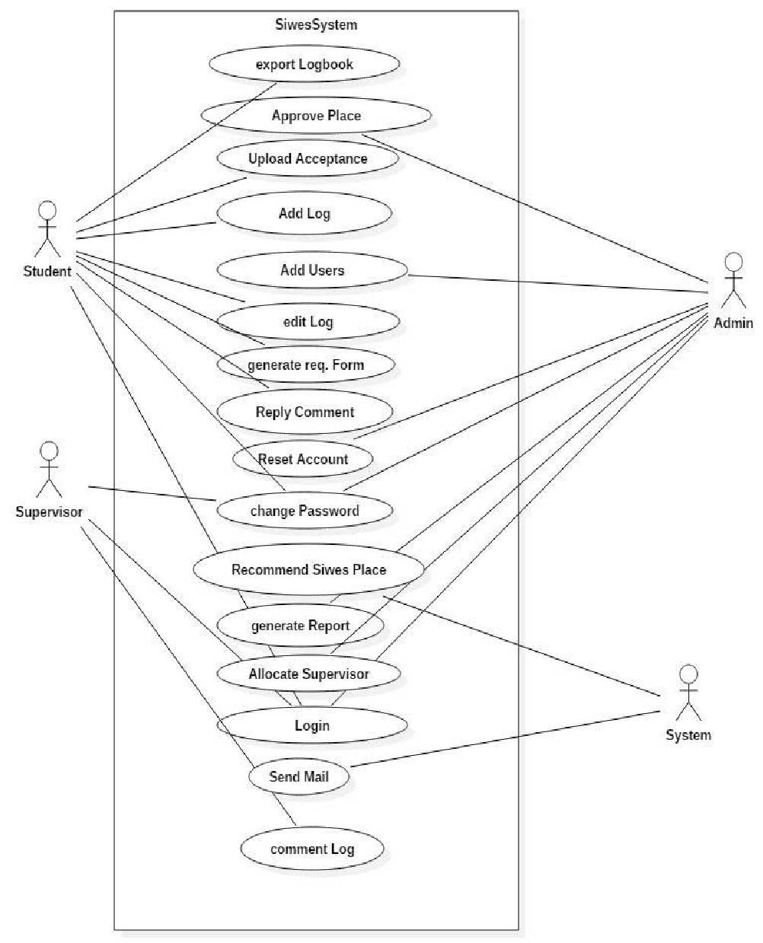

Figure 3.1: Use case diagram

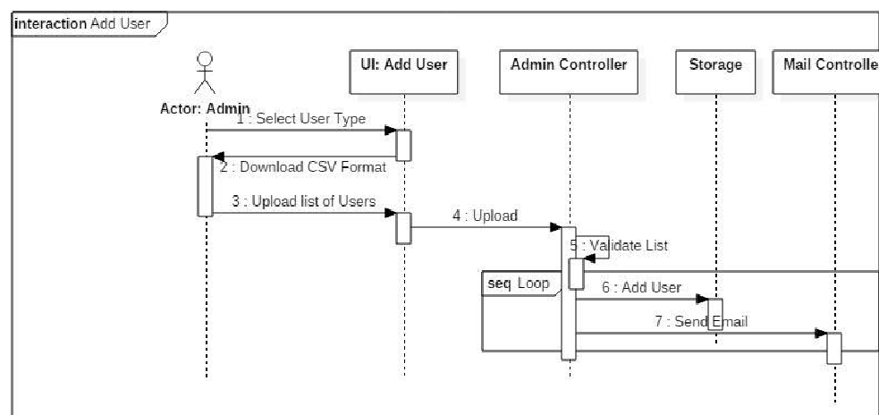Figure 3.2: Login Sequence diagram

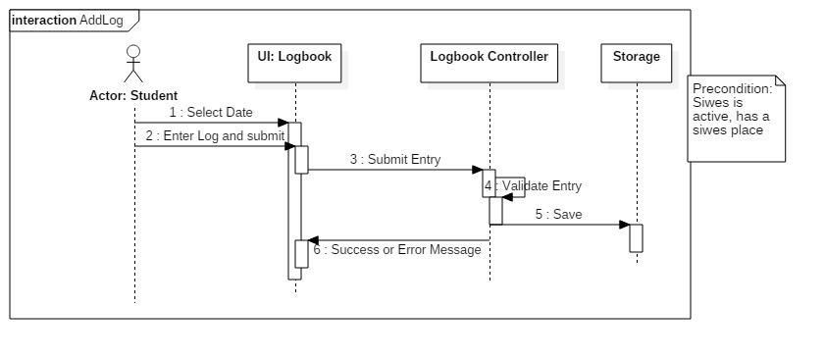

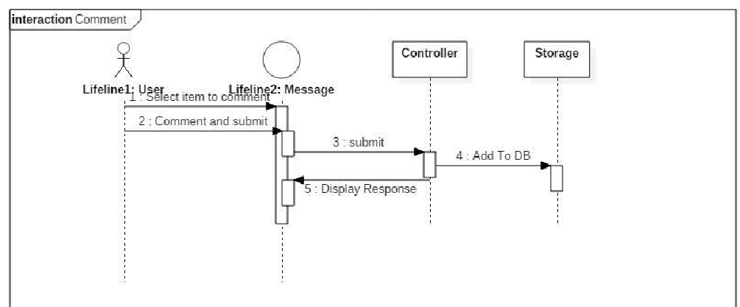Figure 3.3: ​ Add User Sequence Diagram

Figure 3.4: ​Add Log Sequence Diagram

## 3.6.2 System Architecture

Allocate Supervisors, Respond to Student Request/ Complaint, Manage Industry Based Supervisor Account, Post News

Register, Lodge Complaint, View Info, Log Daily Report

View Student Daily Log, Comment on Student Activities

INSTITUTION SIWES DATABASE

Student

**Site Administrator**

Industry Based Supervisor

Institution Based Supervisor

ITF Monitoring Team

Figure 3.6: Architecture of the proposed system

## 3.6.3 Database tables/queries structures

**Table 1: Log books**

Top of Form

| Name | Type | Extra |
| --- | --- | --- |
| logbookId Primary | int(6) | AUTO_INCREMENT |
| logbookMat | varchar(100) |  |
| logbookDesc | text |  |
| logbookAttach | varchar(100) |  |
| logbookComment | text |  |
| logDeleteReason | varchar(100) |  |
| logbookDelete | varchar(100) |  |
| logbookDate | date |  |
| logbookTime | timestamp | ON UPDATE CURRENT_TIMESTAMP() |

Bottom of Form

**Table 2: Staff table**

Top of Form

| **Name** | **Type** | **Attributes** | **Null** | **Extra** |
| --- | --- | --- | --- | --- |
| staffId Primary | int(6) | UNSIGNED | No | AUTO_INCREMENT |
| fname | varchar(100) |  | Yes |  |
| sname | varchar(100) |  | Yes |  |
| mname | varchar(100) |  | Yes |  |
| sex | varchar(100) |  | Yes |  |
| college | varchar(100) |  | Yes |  |
| dept | varchar(100) |  | Yes |  |
| staffno | varchar(100) |  | No |  |
| role | varchar(100) |  | No |  |

**Table 3: Students table**

Top of Form

| **Name** | **Type** | **Null** | **Extra** |
| --- | --- | --- | --- |
| matno Primary | int(11) | No |  |
| reg_num | varchar(500) | No |  |
| fname | varchar(100) | Yes |  |
| sname | varchar(100) | Yes |  |
| mname | varchar(100) | Yes |  |
| sex | varchar(50) | Yes |  |
| college | varchar(100) | Yes |  |
| dept | varchar(100) | Yes |  |
| program | varchar(100) | Yes |  |
| level | varchar(100) | Yes |  |
| studentshipStatus | varchar(100) | Yes |  |
| password | varchar(100) | No |  |

Bottom of Form

**Table 4: Posts table**

Top of Form

| Name | Type | Null | Extra |
| --- | --- | --- | --- |
| siwesPostId Primary | int(6) | No | AUTO_INCREMENT |
| siwesOfficer | varchar(100) | Yes |  |
| siwesMat | varchar(100) | Yes |  |
| siwesCompName | varchar(100) | Yes |  |
| siwesCompAdd | text | Yes |  |
| siwesCompCountry | varchar(100) | Yes |  |
| siwesCompState | varchar(100) | Yes |  |
| siwesCompDate | varchar(100) | Yes |  |
| siwesCompLetter | varchar(100) | Yes |  |

Bottom of Form

## 3.6.4 Input and output design

**LOGIN**

**LOGIN**

Figure 3.7: Login

Registration No.

Student Firstname

**ADD new student**

Student Lastname

Student Middlename

Gender

School

Department

Level

**SAVE**

**CANCEL**

Figure 3.8: Add New Student

Staff Firstname

Staff Lastname

**new sUPERVISOR**

Staff Middlename

Gender

School

Staff Department

Staff ID

Role

**SAVE**

**CANCEL**

Figure 3.9: Add New Supervisor

Select Student

Select Supervisor

**Assign new student**

Organization Name

Organization Address

Organization Country

Organization State

Start Date

Duration (in months)

**SAVE**

**CANCEL**

Figure 3.10: Assign Student

**3.7 System requirement specification**

**3.7.1 Hardware requirement**

The software designed needed the following hardware for an effective operation of the newly designed system.

1. A system running on intel, P(R) duo core with higher processor
2. The-Random Access Memory (RAM) should be at least 512MB.
3. At least 20-GB hard disk.
4. A colored monitor.

**3.7.2 Software Requirements**

The software requirements includes:

1. A window 7 or higher version of operating system.
2. XAMP or WAMP for Database
3. PHP
4. MySQL

**3.7.3 Personnel requirement**

The system was design in such a way that it is user friendly in other to be understood and used by anyone with basic computer knowledge.

# CHAPTER FOUR

# RESULTS AND DISCUSSION

## 4.1 Introduction

The new system is designed using PHP and MySQL programming language for easy records inserting and updating. This system will help in managing and easily retrieving of information from the system for management purposes.

## 4.2 Results

**4.2.1 Welcome Interface**

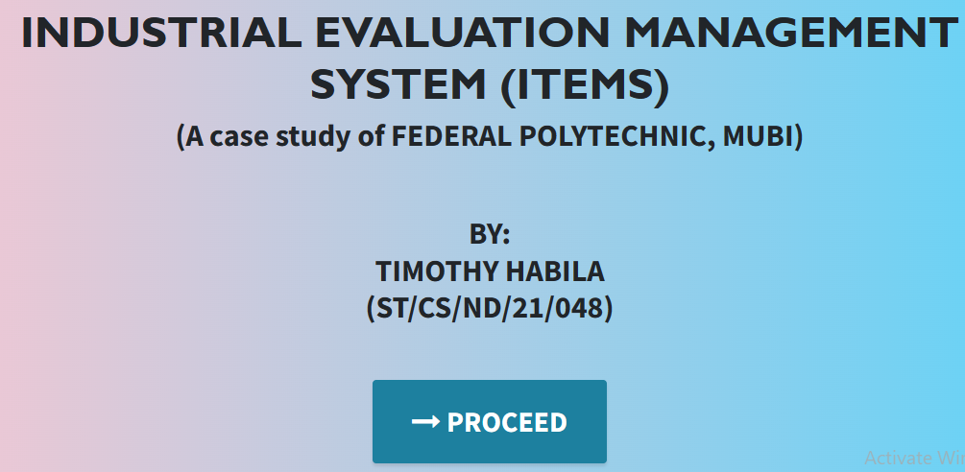

Figure 4.1: Welcome Interface

Figure 4.1 above shows the welcome interface that the user will see, it contains the project topic, student and the supervisor of the project.

4.2.2 Login Interface

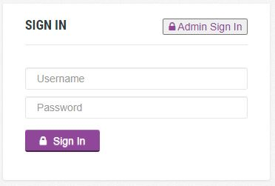

Figure 4.2: Login page interface

Figure 4.2 above is used by an existing admin to login into the system before completing any operation.

**4.2.3 Add supervisor interface**

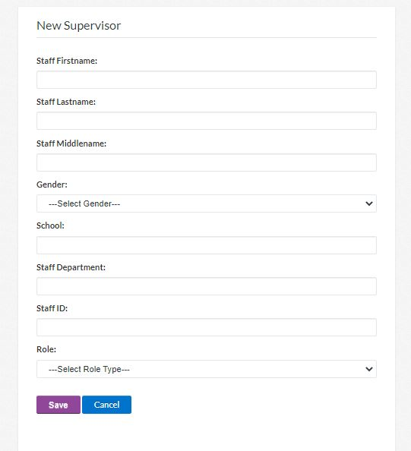

Figure 4.3: Add supervisor interface

Figure 4.2 above is used to add supervisors into the system by the admin

**4.2.4 Add student interface**

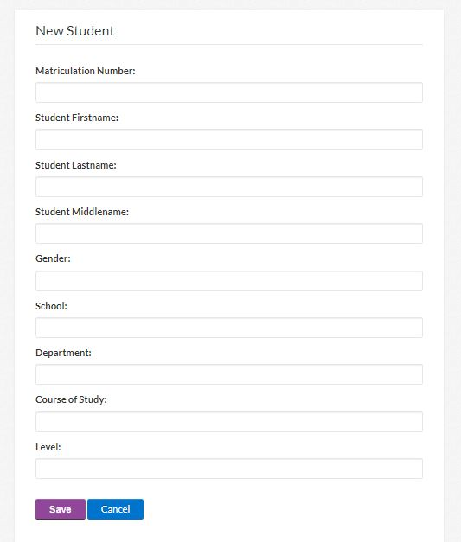

Figure 4.4: Add student interface

Figure 4.4 above is used to add SIWES students into the system

**4.2.5 Supervisor’s student interface**

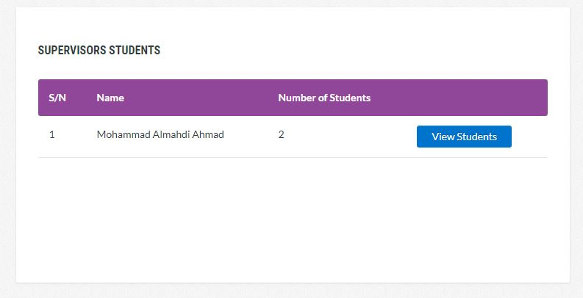

Figure 4.5: Supervisor’s student interface

Figure 4.5 above is used by the supervisor to allocate students who are under his or her supervision.

**4.2.6 Assigned student interface**

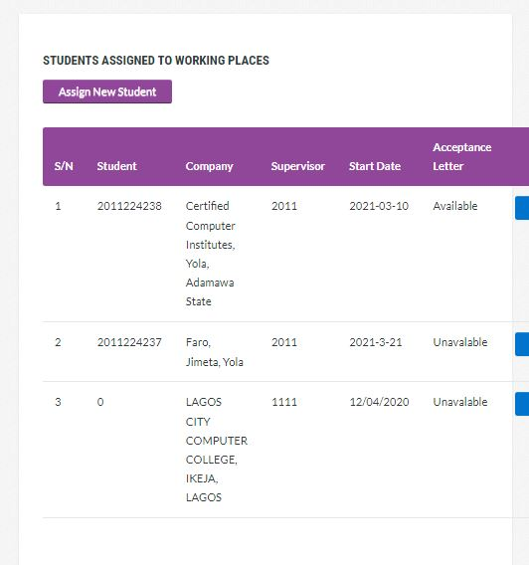

Figure 4.6: Assigned student interface

Figure 4.6 above displays all the students assigned to a particular supervisor

**4.2.7 Admin dashboard interface**

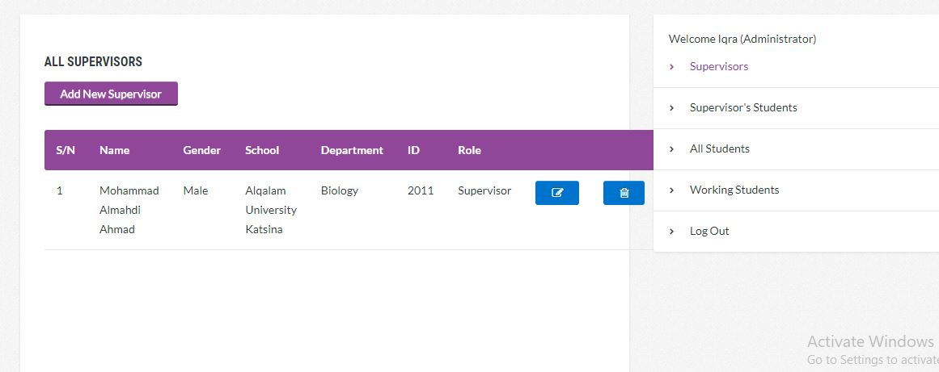

Figure 4.7: Admin dashboard interface

Figure 4.7 above displays the various tasks and activity that can be performed by the admin in the system.

**4.2.8 Student dashboard interface**

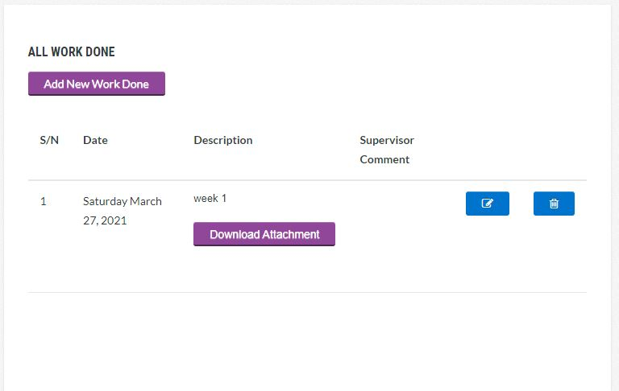

Figure 4.8: Student dashboard interface

Figure 4.8 above displays the various tasks and activity that can be performed by the student in the system.

**4.2.9 Upload activity interface**

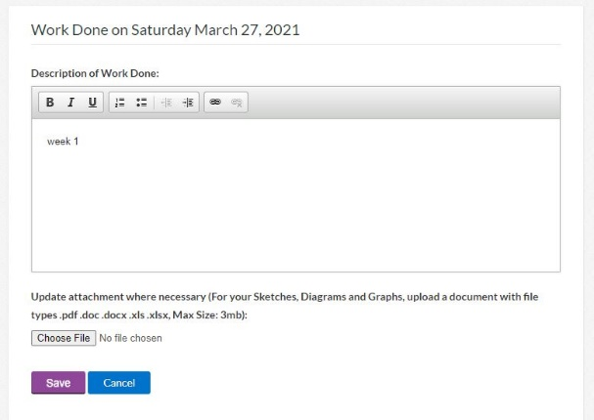

Figure 4.9: Upload activity interface

Figure 4.9 above is used by the student to upload his or her day to day activity.

## 4.3 Discussion

**Supervisor’s student interface**

This section displays all the students assigned to a particular supervisor

**Assigned student interface**

This section displays all the assigned students to a supervisor.

**Add student interface**

This section is used to add students to the system by the administrator

**Add Supervisor interface**

This section is used to add supervisor to the system by the administrator.

**Upload activity interface**

This section is used by the students to upload his or her activity to the supervisor.

**Student dashboard interface**

This section displays the various tasks and activity that can be performed by the student in the system.

**Admin dashboard interface**

This section displays the various tasks and activity that can be performed by the admin in the system.

**Assign students interface**

This section is used by the supervisor to allocate students who are under his or her supervision.

**Welcome interface**

This is the first interface that the user will see, it contains the project topic, student and the supervisor of the project.

**Login interface**

This section is used by an existing admin to login into the system before completing any operation.

## 4.4 User manual

The following are the necessary steps to take in order to use the system efficiently and effectively.

1. Load the url of the system [https://localhost/SIWES PORTAL/](https://localhost/SIWES%20PORTAL/) the welcome page will be displayed.
2. Click on the **Proceed** button to proceed to the main system.
3. If you created an account, provide your login details by entering your username and password.
4. Depending on the login details provided you will be automatically directed to the dashboard.
5. The various task that you can perform on the portal will be displayed on the sidebar of the dashboard.

# CHAPTER FIVE

# SUMMARY, CONCLUSION AND RECOMMENDATION

## 5.1 Summary

The new system was designed in such a way that records about of the student and supervisor and the SIWES activities will be stored in a database for easy retrieval and manipulation of data that can be accessible from any place reducing the overcrowding and easy retrieval of the students’ SIWES records in the database.

## 5.2 Conclusion

The Electronic SIWES logbook was designed and implemented, the aim and specific objectives of the project were achieved successfully.

## 5.3 Recommendations

The researcher puts forward the following recommendations:

1. The school management should imbibe the use of this technology in carrying out her tasks in order to reduce the time wastage that is involved with the manual system.
2. The researcher also recommends that the system be put to effective use in order to derive the necessary efficiency of the system.

## 5.4 Contribution to knowledge

The new system was designed in a structured and robust way employing responsive design to it to ensure usability and efficiency. The project research will serve as a reference point for other research work and contribute immensely to knowledge for those conducting a research on similar topic.

## 5.5 Area for further work

The research work limited to computer science department only. Therefore, the researcher suggests that further studies be conducted to include other departments in the Polytechnic.

# REFERENCES

Abdullahi, I. (2019). The Personal Research Portal: *Driven Individual commitment with open access development, Knowledge Management for Development Journal, 3(1),* 35-48.

Abraham, M. (2015). *Mega-Universities and Knowledge Media –Technology Strategies for Higher Education*. Kogan Page: London.

Adetiba, T. (2012). A Collaborative Students’ Industrial Work Experience Scheme (SIWES) Supervision and Management Platform: A Cloud-Based Solution,” International Journal of Technology Advancement, 2(3), 16-20.

Aggarwal, U. (2017). The use of electronic information services by students at Glasgow Caledonian University. *Emerald Group Publishing Limited. Vine, 34(3),* pp. 113-118.

Avouris, Y. (2012). In Merriam-Webster.com dictionary. Retrieved October 21, 2020, from https://​www.merriam-webster.com/​dictionary/​citation

Bevan, K. (2017). Exploring user perception of wireless. *Campus International Journal of Mobile Communications. Volume 5,(6),* 710- 730.

Brayand, N. (2014). *About Web Portals*: A home page doth not make a portal. Jossey-Bass, A Wiley Company.

Dennis, E. (2016). Remaking the Academy: Twenty-First Century Challenges to Higher Education in the Age of Information. *Educause Journal Review 35(2).*

Joseph, N. (2016). The Personal Research Portal: *Web Driven Individual commitment with open access development, Knowledge Management for Development Journal, Amsterdam, 3 (1),* 35-48.

Lee, L. (2012). *About Web Portals*: A home page doth not make a portal. Jossey-Bass, A Wiley Company

Mafe, J. (2019). Collaborative and content-based filtering for item recommendation on social bookmarking websites, vol. 532. 2009.

Nielsen, R. (2012). *Development of Online Student Course Registration System*. Retrieved January 16, 2016 from [www.cren.net/know/techtalk/events/](http://www.cren.net/know/techtalk/events/portals.html)

Ojokulu, P. (2015). Literature Review: Website Design and User Engagement,” Online J. Commun. Media Technol., vol. 6, no. 3, pp. 131–147, 2016.

Oyeniyi, K. (2012). Portals in higher education. *Educause Journal Review, 35(4).*

Palmer, O. (2020). *Using Technology to make a step-in business efficiency and responsiveness*. Regional Support Centres, London.

Rao, U. (2013). Portals in higher education. *Educause Journal Review, 35(4).*

Reus, K. (2013). *Discovering Computers*: A Gateway to Information, Web Enhanced Complete. Thomson Course Technology. USA

Ukwueze, O. (2016). Development of Online Project Registration and Management System. *Campus-Wide Journal of Information Systems, 24(5),* 342-354. doi:10.1108/10650740710835760.

Zachariah, K. (2016). *Availability, accessibility and use of ICT in management of students ‘academic affairs in Makerere University*, Makerere University.

# APPENDIX A

Welcome interface



Figure 4.1: Welcome interface

Login interface



Supervisor’s student interface



Add supervisor interface



Figure 4.3: Add supervisor interface

Add student interface



Assigned student interface



Admin dashboard interface



Student dashboard interface



Upload activity interface



# APPENDIX B

**PROGRAM CODE**

<!DOCTYPE html>

<html lang="en">

  <head>

    <meta charset="utf-8">

    <meta name="viewport" content="width=device-width, initial-scale=1, shrink-to-fit=no">

    <meta name="description" content="">

    <meta name="author" content="">

    <title>SIWES PORTAL</title>

    <!-- Bootstrap Core CSS -->

    <link href="vendor/bootstrap/css/bootstrap.min.css" rel="stylesheet">

    <!-- Custom Fonts -->

    <link href="vendor/font-awesome/css/font-awesome.min.css" rel="stylesheet" type="text/css">

    <link href="https://fonts.googleapis.com/css?family=Source+Sans+Pro:300,400,700,300italic,400italic,700italic" rel="stylesheet" type="text/css">

    <link href="vendor/simple-line-icons/css/simple-line-icons.css" rel="stylesheet">

    <!-- Custom CSS -->

    <link href="css/stylish-portfolio.min.css" rel="stylesheet">

  </head>

  <body id="page-top" style="background:rgb(252, 144, 4);">

    <!-- Navigation -->

    <a class="menu-toggle rounded" href="#">

      <i class="fa fa-bars"></i>

    </a>

    <nav id="sidebar-wrapper">

      <ul class="sidebar-nav">

        <li class="sidebar-brand">

          <a class="js-scroll-trigger" href="#page-top">SIWES PORTAL</a>

        </li>

        <li class="sidebar-nav-item">

          <a class="js-scroll-trigger" href="Electronic-siwes-logbook/">Proceed</a>

        </li>

    </nav>

    <!-- Header -->

    <header class="masthead d-flex">

      <div class="container text-center my-auto">

        <h1 class="mb-1" style="font-size: 30px; text-transform: uppercase;"><span style=" font-size: 30px; margin-top: 25px;"> DESIGN AND IMPLEMENTATION OF AN ELECTRONIC LOG BOOKS FOR STUDENT INDUSTRIAL WORK EXPERIENCE SCHEME (SIWES)</span> <br> <br> <br> </h1>

        <h3>BY: <br> ST/CS/ND/19/300, ST/CS/ND/19/314, ST/CS/ND/19/318 </h3> <br> <br>

        <h3>SUPERVISED BY: <br>MALLAM NUHU ABDULLAHI

        </h3>

        <br><br><br>

        <strong><a class="btn btn-primary btn-xl js-scroll-trigger" href="Electronic-siwes-logbook/" style="font-size: 20px;"><span class="fa fa-long-arrow-right"></span> PROCEED</a></strong>

              </div>

      <div class="overlay"></div>

    </header>

    <!-- Scroll to Top Button-->

    <a class="scroll-to-top rounded js-scroll-trigger" href="#page-top">

      <i class="fa fa-angle-up"></i>

    </a>

    <!-- Bootstrap core JavaScript -->

    <script src="vendor/jquery/jquery.min.js"></script>

    <script src="vendor/bootstrap/js/bootstrap.bundle.min.js"></script>

    <!-- Plugin JavaScript -->

    <script src="vendor/jquery-easing/jquery.easing.min.js"></script>

    <!-- Custom scripts for this template -->

    <script src="js/stylish-portfolio.min.js"></script>

  </body>

</html>